Capstone Milestone Report

Alex Levy
October 20, 2025

Goal 1: Training Data Loading and Pre-Processing – Completed
- As outlined in the proposal, the pre-processing step loads the data from the local directory into a torchvision ImageLoader instance, and then I use built-in transformations (grayscale, normalization, and tensor transformations) to pre-process into the format I need to train.
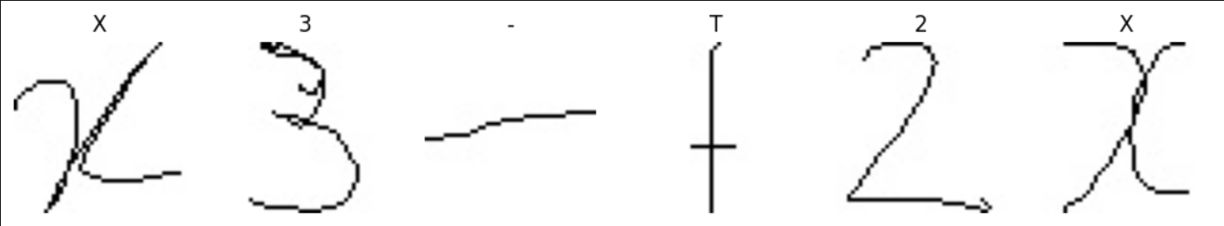
- Unfortunately, the data is not evenly distributed, which might raise some problems later.
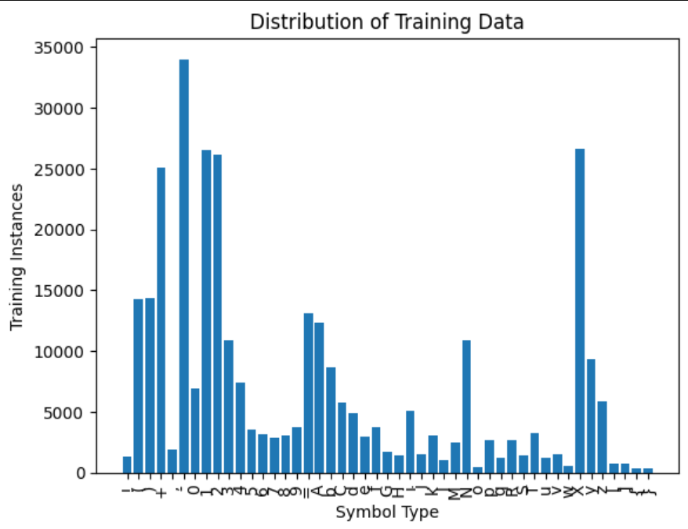
Goal 2: Classification and Model Training – Completed
- I trained a convolutional neural network to perform the classification. It took me a few tries to get the model to perform at an acceptable level. I used the Adam optimizer with 2 convolutional layers and 2 dense layers. I then implemented early stopping by measuring validation loss after each epoch and trained the model over ~12 hours. From the graph, we can see that the model plateaud in accuracy at around epoch 11. From my data, it finished training with a test accuracy of 99.05%.

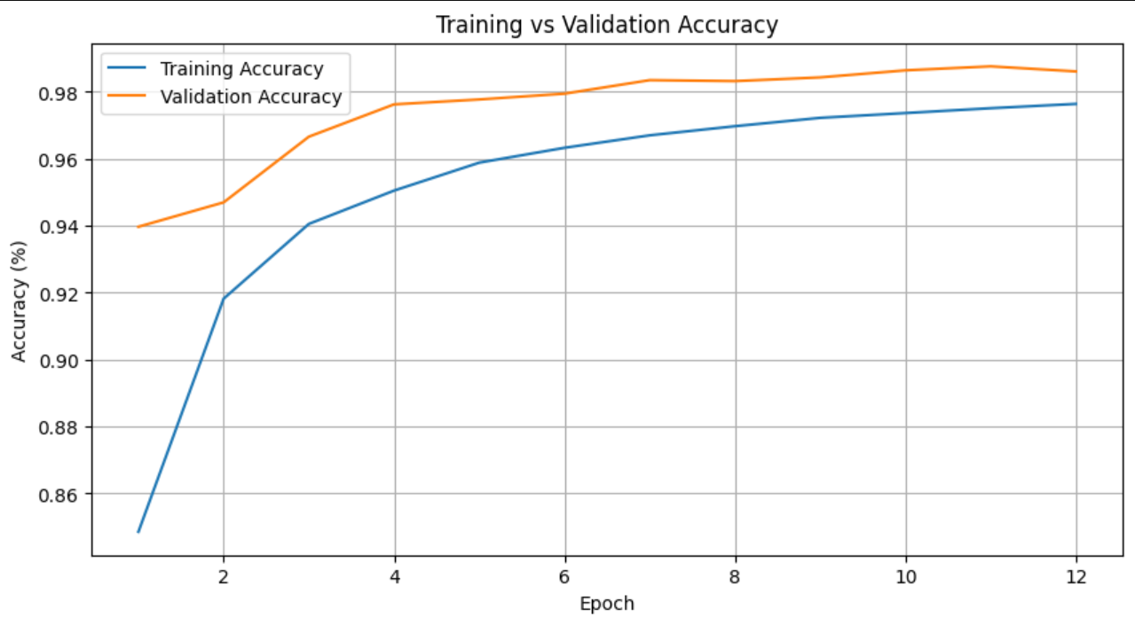
- The high accuracy is corroborated by nice-looking confusion matrices for most classes.
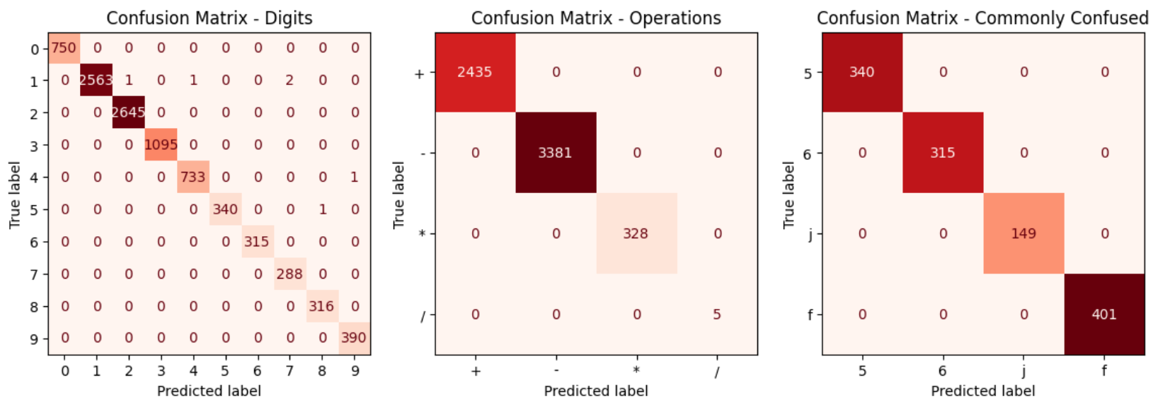
Goal 3: Applying Model to Handwritten User Input – In Progress
- The original goal of this project was to apply the classification to handwritten math expressions, converting them to a symbolic representation to perform operations on. Towards this goal, I created an interactive canvas in the Jupyter Notebook application that successfully takes user input. I’m having trouble applying the correct transformations to isolate each symbol in the expression and then convert them to the same format expected by the model. This was an unexpected technical challenge.
- Currently it works nicely for some input. For example, this drawing I made is converted successfully, but some more complex expressions aren’t.

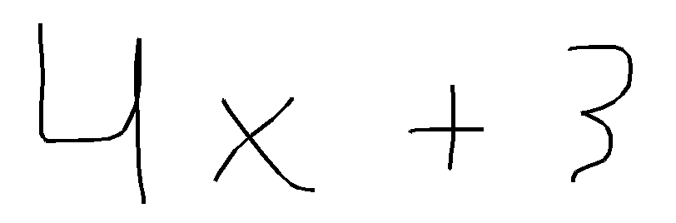

- Each symbol is successfully isolated, and the classification is successful:
